e-Portfolio Activity: Model Performance Measurement
Measuring model performance is a critical step in the machine learning pipeline to ensure that a model is accurate and generalisable to unseen data. The performance of a Support Vector Classifier (SVC), through the confusion matrix and ROC curve, was evaluated in this activity. We varied three parameters, changing the train test split ratio values, regularisation parameter C, and kernel type to see what makes a difference to the model's performance.
After splitting the data with a 70:30 training and testing ratio, the model showed considerable differences in its classification capability. A confusion matrix showed that the model predicted all instances as belonging to a single class, with 18 false positives but no true negatives, indicating too great a disparity between predictions of different courses. It was possibly due to class imbalance or insufficient training to enable sufficient parameter tuning.
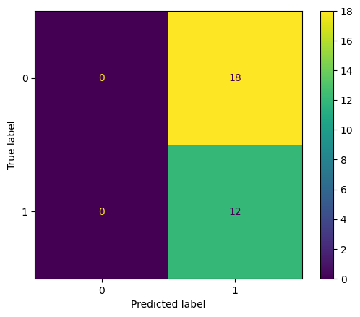
This was done to see how the decision boundary changes as the regularisation strength (C) are 0.1. As we simplified in the model, we underfitted, reflected by the poor classification of class 0. Lastly, the kernel was changed from a polynomial (poly) type to introduce non-linear decision boundaries to handle complex data patterns. The (ROC AUC) of 0.85 increased. Still, the confusion matrix showed that there remain true negatives, meaning threshold-based predictions alone will omit too many real negatives.
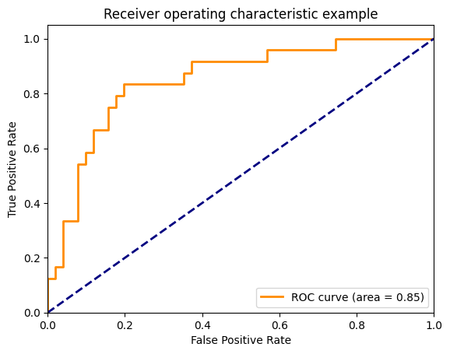
These results reveal that parameter tuning and facing class imbalance are critical areas. Although the AUC of the model of 0.85 suggests that it discriminates classes with a moderate to reasonable difference, the confusion matrix indicates an improvement at some additional level in a form such as class weights or an advanced technique such as oversampling. The activity evaluated these changes systematically to understand how parameter selection affects the tradeoff between model complexity and predictive performance.

